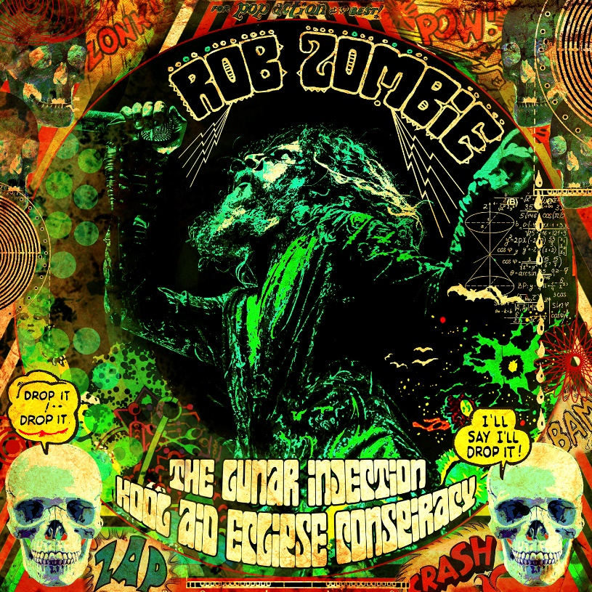

ROB ZOMBIE
»The Lunar Injection Kool Aid Eclipse Conspiracy«

OUT: March 12th 2021

Line-up: | ROB ZOMBIE online:
Rob Zombie - vocals  John 5 - guitar  Piggy D - bass  Ginger Fish - drums | www.robzombie.com www.facebook.com/robzombie www.twitter.com/robzombie www.instagram.com/robzombieofficial

As a rock icon and filmmaker with a unique vision, ROB ZOMBIE has continuously challenged
audiences as he stretches the boundaries of both music and film. He has sold more than
fifteen million albums worldwide, and is the only artist to experience unprecedented success
in both music and film as the writer/director of eight feature films with a worldwide gross
totaling more than $150 million.

MUSIC
ROB ZOMBIE has achieved great success in the music industry, first as a member of the
multi-platinum band WHITE ZOMBIE and later as a solo artist with even greater results
collecting numerous multi-platinum and gold albums along the way including Hellbilly
Deluxe , The Sinister Urge and Educated Horses . In 2013, the seven-time GRAMMY®
nominee released his fifth solo album, Venomous Rat Regeneration Vendor , on his Zodiac
Swan label through UMe. The album debuted at No. 7 on the Billboard 200 and spawned
two Top 10 Active Rock singles, “Dead City Radio and the New Gods of Super Town” and
ZOMBIE ’s spin on GRAND FUNK RAILROAD ’s anthemic “We’re An American Band.”
ROB ZOMBIE ’s first concert film, The Zombie Horror Picture Show, was released May 19 2015
by Zodiac Swan/UMe . The feature-length film held the No. 1 spot on Billboard’s Music DVD
chart for two consecutive weeks. Recorded live over two sizzling nights in Texas, The Zombie
Horror Picture Show captures ZOMBIE 's elaborate, multimedia production of mind-blowing
SFX, animatronic robots, pyrotechnics, oversized LED screens and state-of-the-art light show
combined with his powerhouse band featuring John 5 , Piggy D and Ginger Fish.
In April 2016, ZOMBIE released his 6th studio album, The Electric Warlock Acid Witch Satanic
Orgy Celebration Dispenser. The album debuted at number six on the Billboard Top 200
making it the sixth consecutive release to debut Top Ten. Produced by Zeuss , it was recorded
and mixed at Goathouse Studios. A full return to form by the rock icon, The Electric
Warlock … features John 5 (Guitar), Piggy D (Bass) and Ginger Fish (Drums).
October 2020 sees the release of the first new ZOMBIE track and video in over four years —
“King Freak: A Crypt Of Preservation And Superstition” off of the forthcoming full-length
album entitled The Lunar Injection Kool Aid Eclipse Conspiracy. A classic ZOMBIE album
through and through with high-energy rages like The Eternal Struggles of the Howling Man
and Get Loose to heavy-groove thumpers like Shadow Of The Cemetery Man and Shake
Your Ass-Smoke Your Grass . This new slab of ZOMBIE madness hits in early 2021.

MOVIES
ROB ZOMBIE has proved an undeniable box office success with his re-imagining of John
Carpenter ’s Halloween in 2007, which premiered at #1, and 13 years later still holds the
Labor Day Weekend box office record. Having breathed new life into the Halloween
franchise, he also helmed Halloween 2 ( Dimension ), in August 2009, notably departing from
the originals by delving into the ill-fated childhood of Michael Myers . Prior to that, ZOMBIE
wrote and directed the 2004 cult favorite House of 1000 Corpses (Lionsgate) and its
companion, 2005’s critically acclaimed The Devil’s Rejects (Lionsgate), which chronicles the
mayhem of the psychopathic Firefly family . ZOMBIE returned to the family for the third
installment in September of 2019 entitled 3 From Hell (Lionsgate, Saban Films) .
In addition, ZOMBIE also developed his own comic book series into an R-rated animated
feature, The Haunted World of El Superbeasto ( Starz ). In 2016, ZOMBIE premiered his 7th
film, 31 ( Saban Films ), at Sundance Film Festival .
ROB ZOMBIE partnered with producer Jason Blum on The Lords of Salem , which premiered
at the 2012 Toronto International Film Festival . A novel based on the film’s original story
was also co-penned by ZOMBIE , and debuted on the New York Times Best Seller list.
For the past two decades ROB ZOMBIE has also directed dozens of music videos for himself
as well as other artists including Ozzy Osbourne . ZOMBIE was also the first self-directed
artist to win an MTV Video Music Award . He’s also directed a special episode of CBS ’s CSI:
Miami , two Comedy Central specials, and uncharacteristically macabre commercials for
various brands.

